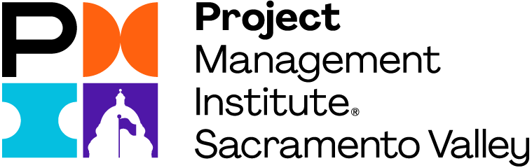

Mission Statement of PMI-SVC Programs
Engage youth, students, academic institutions, non-profit organizations, and current and former military personnel and spouses to bring awareness of project management to inspire the next generation of changemakers.

Social Good Internships
ROLE DESCRIPTION: Lead meaningful change in the community and build your project management skills by volunteering as a Social Impact Intern. You will act as the project manager for a specific volunteer effort to support the Sacramento Valley Chapter’s social good initiative.
PROJECT REQUIREMENTS: Plan and lead a social good initiative with a specific goal and target. Projects will be discreet efforts to be planned, executed and closed out within the duration of the internship. The project should provide positive impact on the community, opportunities for PMI-SVC members to engage, and an opportunity for the intern to implement project management.
EXAMPLE PROJECTS: Collection drive, grant application, community clean up, day of giving.
EXPERIENCE GAINED: Experience as a project manager throughout the lifecycle of the project, with support and mentorship by one or more Board members. Experience in planning and communication, and additional experience depending on the interests of the intern.

EXPECTED DELIVERABLES:

- Project Description
- Project Scope and Goals
- Project Charter
- Roles and Responsibilities
- Schedule
- Budget (money and effort)
- Communication Plan
- Quality Control Plan
- Risk Management Plan
- Lessons Learned
- Board Briefing
- Project Artifacts

RESOURCES AVAILABLE:
- Year membership to PMI Global and Local Chapter
- Mentorship from Board Member/s
- Support of logistic costs and refreshments

Contact Information
For more information about this internship, please contact
Melissa Harris, Vice-President of Programs at vpprograms@pmi-svc.org

